INFORMATICA POWERCENTER 9.6 INSTALLATION MANUAL

**System Requirement**: This installation manual is for Windows 7 64 bit system.

**Prerequisites:**

1) A preinstalled oracle database is required to hold the domain configuration tables and repository tables for informatica. The copy of Oracle 11g Enterprise edition or Oracle XE edition 11g can be downloaded from Oracle website. Below is the link:

<http://www.oracle.com/technetwork/database/enterprise-edition/downloads/112010-win64soft-094461.html>

After downloading the file, please install the Oracle database and create two users / schemas.

* Domain configuration data: infa_dom

CREATE USER infa_dom IDENTIFIED BY infa_dom

* Repository service tables: infa_rep

CREATE USER infa_rep IDENTIFIED BY infa_rep

Also grant appropriate permissions to them.

2) Download Sql developer from below link:

<http://www.oracle.com/technetwork/developer-tools/sql-developer/downloads/index.html>

3) Informatica installation zip files can be downloaded from Oracle e delivery website

<https://login.oracle.com/mysso/signon.jsp>

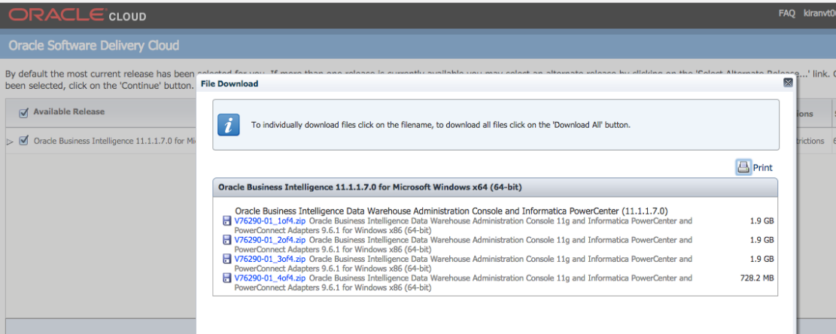

This is how the files will look at your system, these are zip files. We need to unzip them using WINRAR.

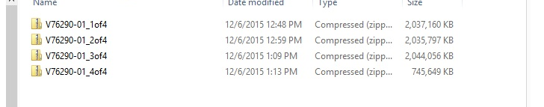

The last one is the base file and Z01, Z02 and Z03 are its different volumes. Extract only the base file; it will automatically extract all its volume.

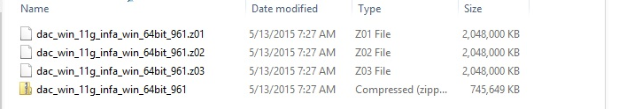

Now we have below zip files one for server, client each and an installation key.

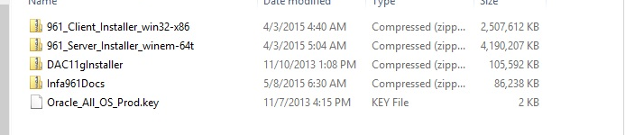

We start by extracting server and client Zip files and we will have following files ready with us.

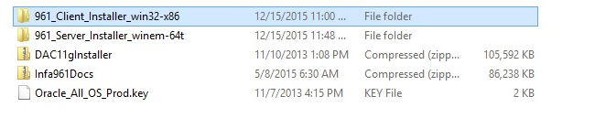

**INSTALLATION OF POWERCENTER SERVICES**

To install informatica powercenter services we will open the server folder and run the install exe file.

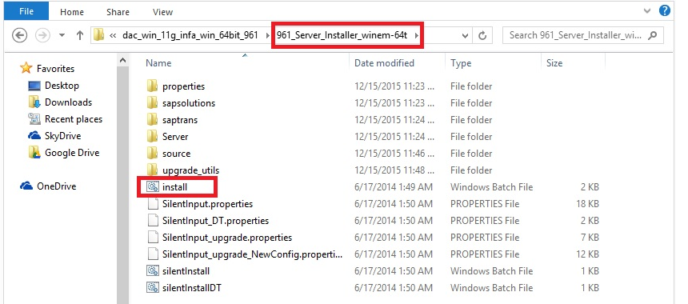

We should perform the system check always before we move on with installation. Below will be the steps that will be required for a successful installation.

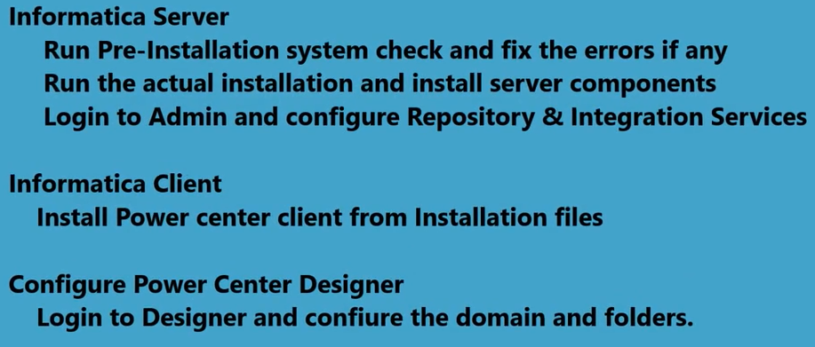

So we will start with server installation with pre installation check and below will be the first screen you will see on click server install exe file.

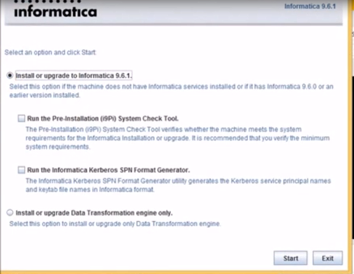

We will check the option for pre installation system check tool and click on start button as shown in below screenshot.

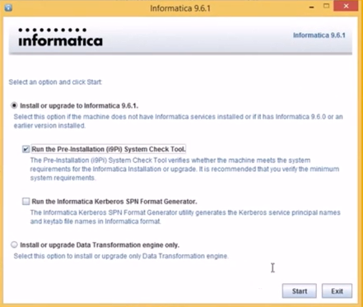

The next screens will be as shown below.

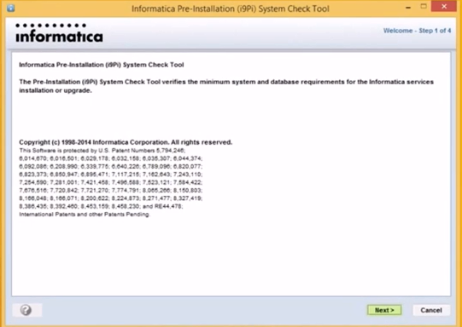

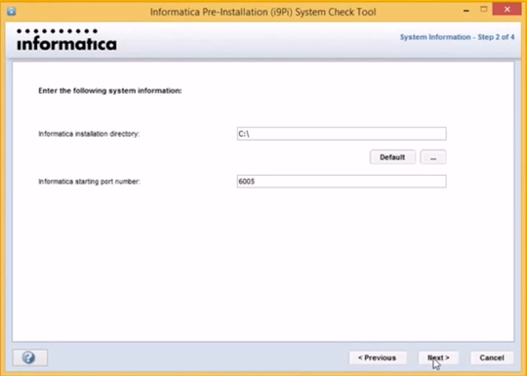

Enter the Domain database details; this will be the one that we created after oracle database installation which will be as follows and then click on next:

Type: Oracle

User ID: infa_dom

Password: infa_dom

Hostname: localhost

Port number: 1521

Service name: orcl

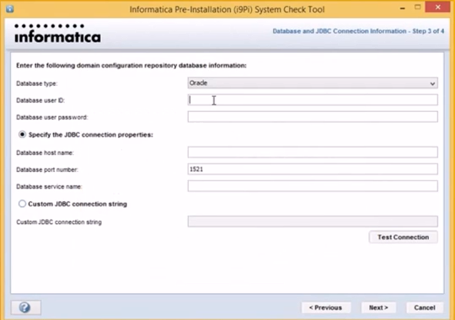

After clicking next we will get the screen as shown below with the system check tool results, there are two errors we can see in this installation.

**The first one with operating system error should be ignored as the installation will work with windows 7 or 8 systems.**

We should take a look at second one which says “**OPEN CURSORS SHOULD BE SET TO 1000 OR HIGHER**”

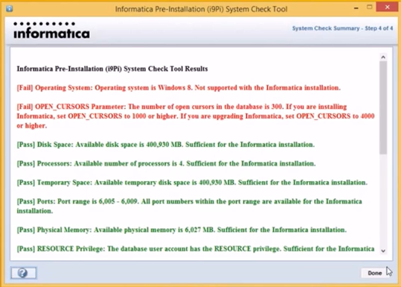

To resolve this go to CMD and connect to database and execute below command: ALTER SYSTEM SET OPEN_CURSORS=1000 SCOPE=both;

Below is the screenshot:

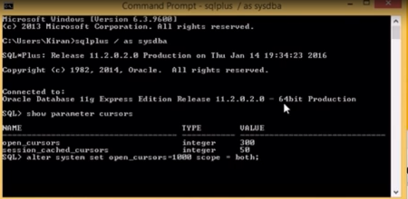

Once done we should stop and start the database again.

**For express edition: we can do it directly from start menu.**

**For enterprise edition: we can do it using SHUTDOWN normal and STARTUP commands.**

**After restarting the database we should check again using command:**

**Show parameter cursors;**

**It should show 1000.**

Now we are good to run the pre installation check again and verify the results which will look like below:

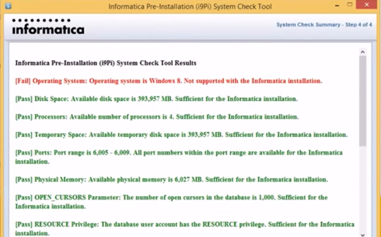

So we are good with results now and we should ignore the first error as installation will run fine with windows 7 or 8.So we will go ahead with installation which will be guided with below screenshots:

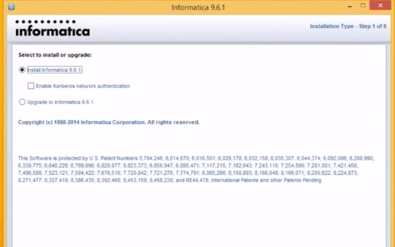

Click on next and it will ask for License key which was there in installation folder.

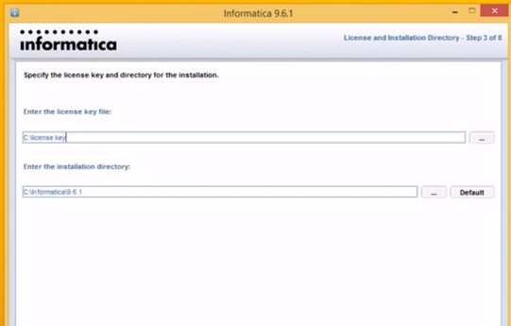

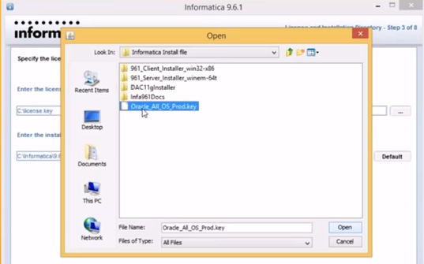

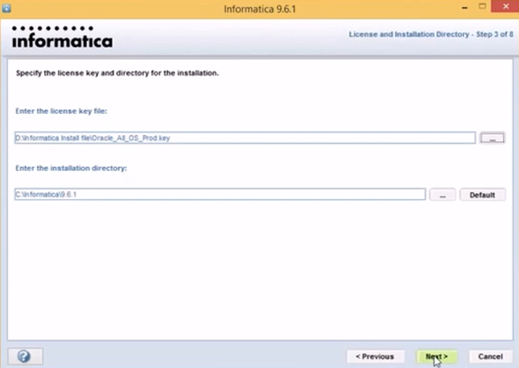

Click on next.The next screen will be below.

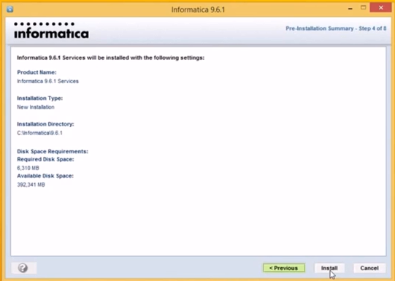

Click on install and installation begins. Below would be the screenshot you will see.

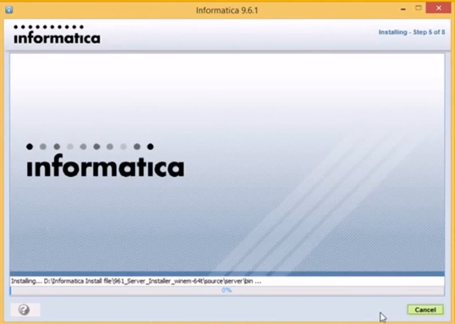

The next screen would be of creating the Domain.

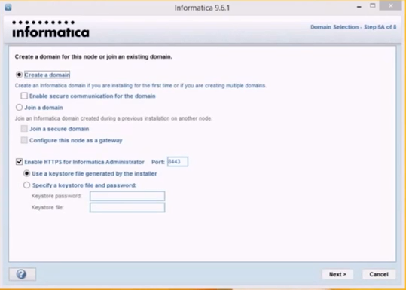

Uncheck the option “Enable HTTPS for Informatica Administrator” and click next. The next screen would be asking for database details for Domain configuration database:

Database user ID: infa_dom

Password: infa_dom

Database Address: localhost.1521

Service: xe (express edition), orcl (enterprise edition)

Test the connection after entering details and click next.

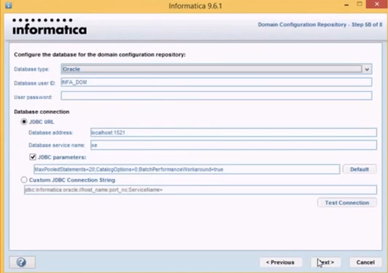

The below screen will ask for keyword, you can give any say “myetlinfa” or “hidatawarehousing” etc. Click on next.

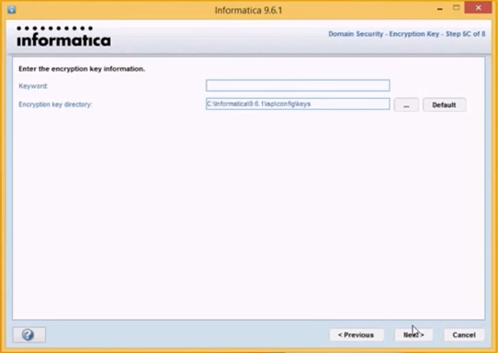

The next screen as you can see below will list the domain information, you can enter the password which you will use to login to informatica administrator. Click next after entering password and also check the box “Display advance port configuration page”

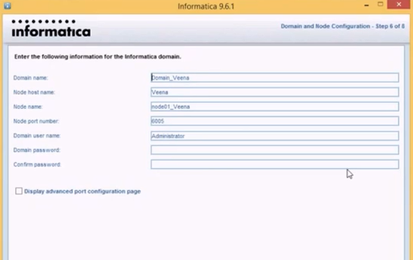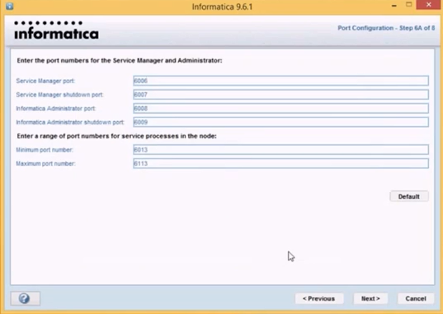

Click next and below screen will appear. Uncheck the box “Run Informatica under a different user account” and click next.

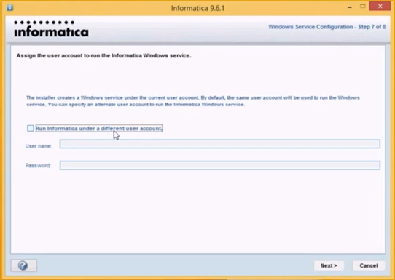

After that the final page will appear indicating the successful installation of server.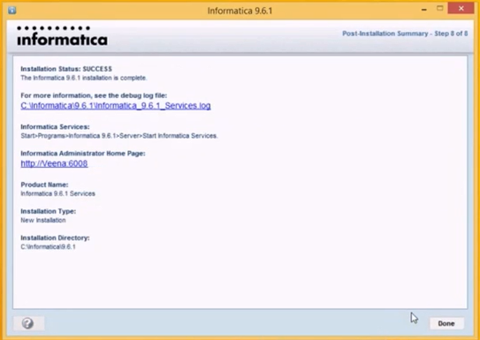

This marks the successful installation of informatica services on our machine and we should log on to informatica administrator web page which will there on installation success page to create:

REPOSITORY SERVICE

INTEGRATION SERVICE

The password and username should be the one that we entered during installation.

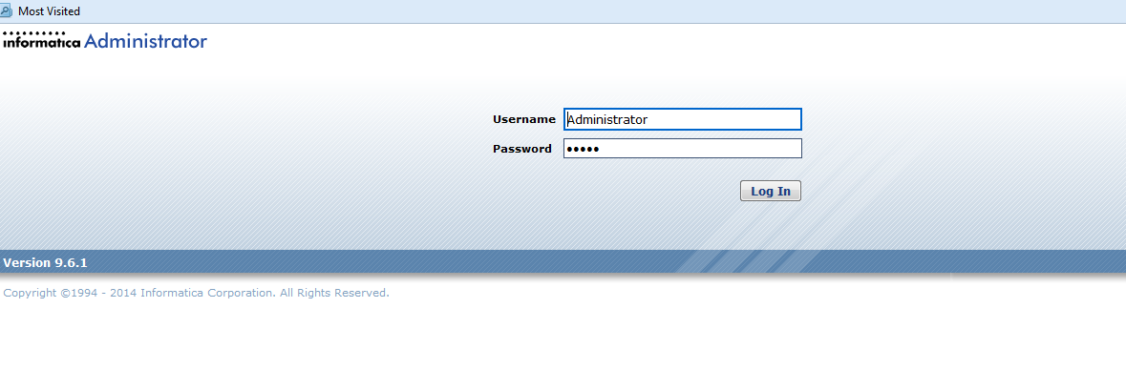

After logging in we will see below screen. Under Actions click on New 🡪Powercenter Repository service

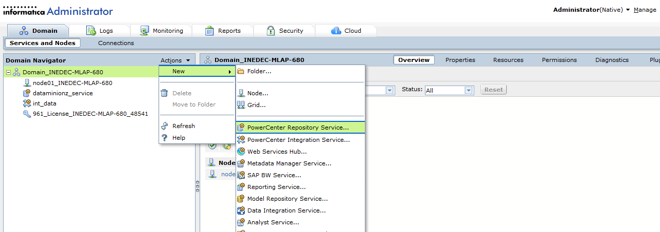

We will enter the details such as repository name, description and location by default will be your domain that was created during installation and we will have to select the license and the node which will be your machine on which installation is done. After that we will click on next .

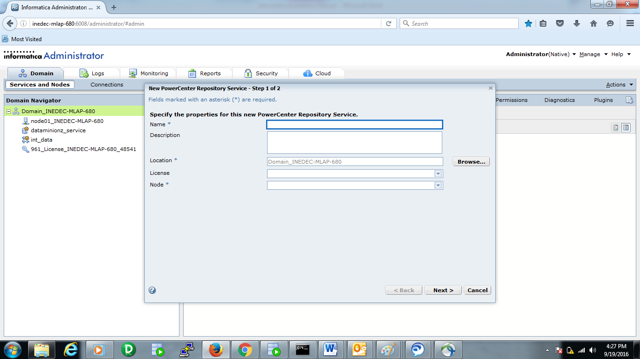

In the next screen we will specify the database properties for powercenter repository service:

Database type: Oracle (in current scenario)

Username: Schema/user created after installing database (infa_rep in our case)

Password: password for this user (infa_rep)

Connection string: name of oracle service (orcl or xe)

Code page: how the characters will be interpreted

Also select “No content exit under specified connection string. Create new content”

Also select “Enable version control” AND CLICK finish.

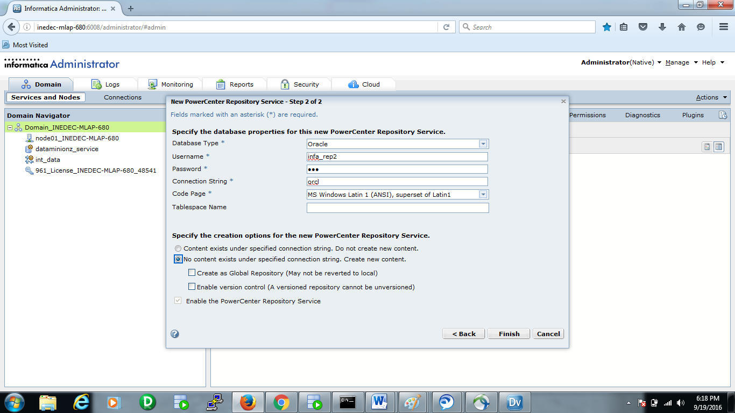

Once we have created the repository service we should change the mode from EXCLUSIVE to NORMAL by editing the service properties.

Next step would be to create the integration service by associating it the repository service we created before.

We can create multiple integration services for a single repository service.

Also we can create multiple repository services by creating new schemas/users in database and each repository service will point to a new repository database.

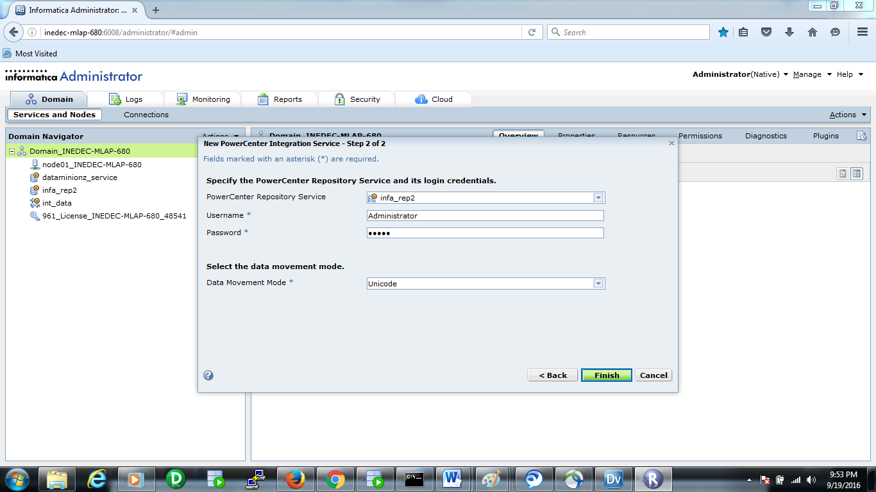

So finally below is what a informatica domain will look like having multiple integration services and repository services installed on a single node which is the logical representation of your standalone machine or laptop on which you are doing installation.

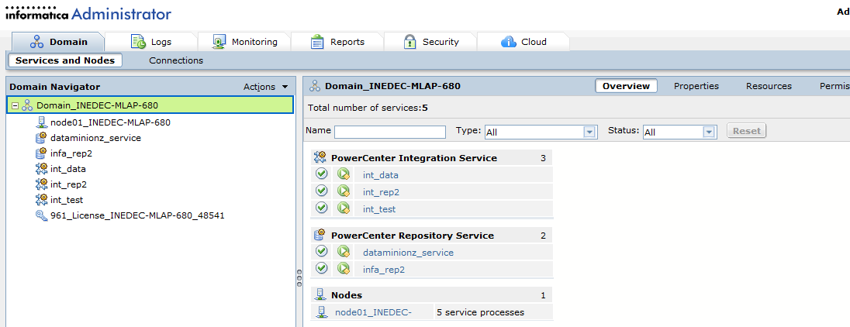

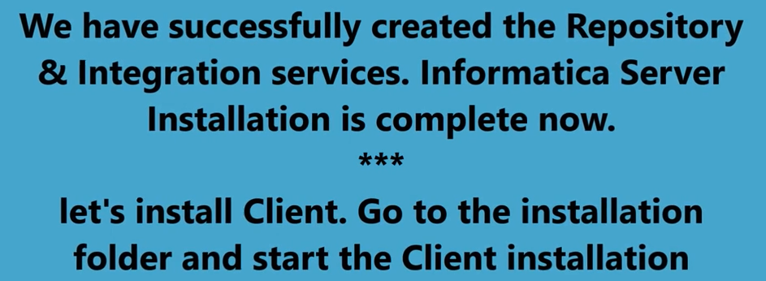

INSTALLATION

OF

POWERCENTER

CLIENT

We can start with client folder and click on install exe file.

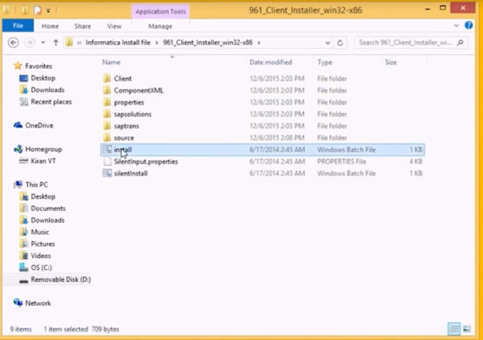

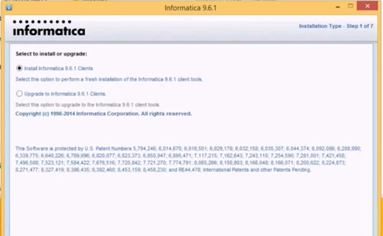

We can select the various client that are shipped with this installation, please select Powercenter client and click next.

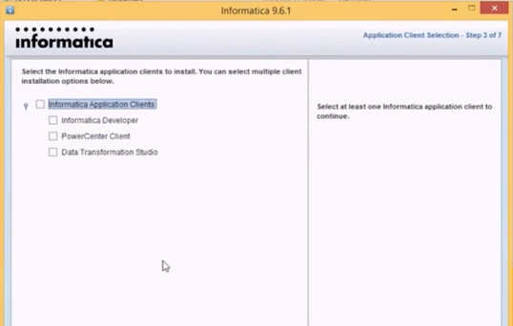

Enter the installation directory and press next.

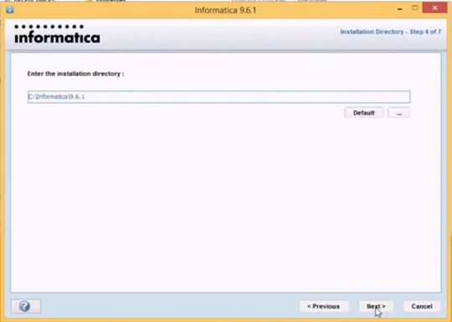

Installation begins….

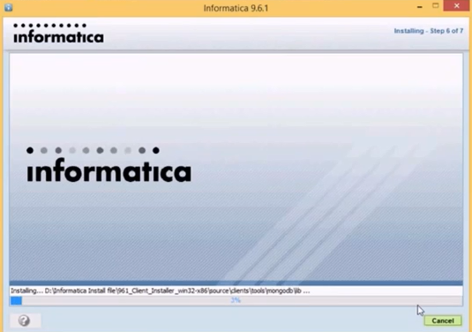

The final message would be below.

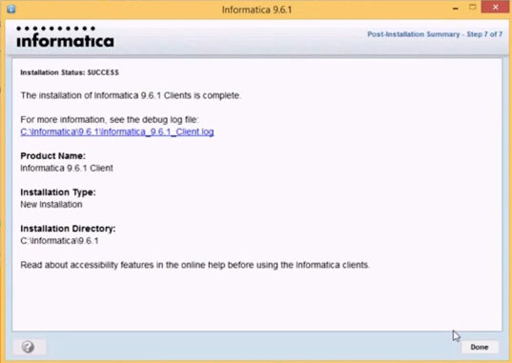

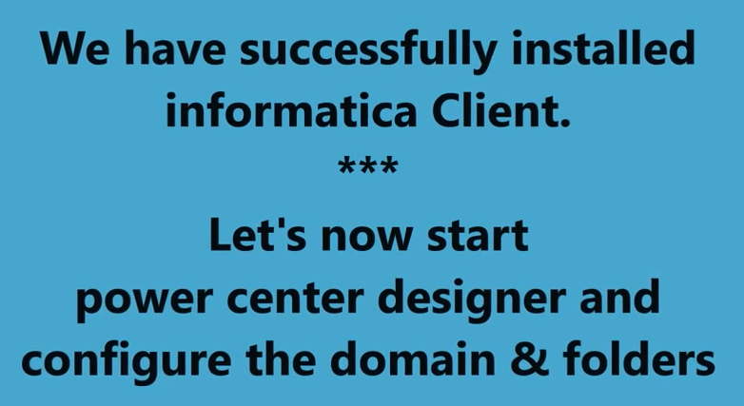

CONFIGURATION

OF INFORMATICA DOMAIN

AND FOLDER

Open Repository Manager Client tool and go to Repository -- >Configure Domain

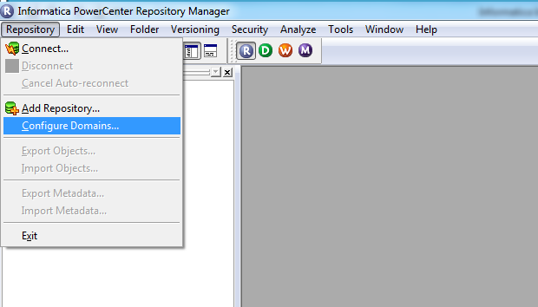

Below window will appear.

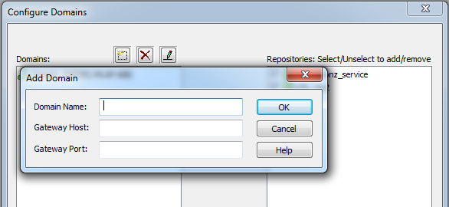

Enter the domain name, gateway host (name of your machine) and port (6005).

Click ok.

The Associated repositories will appear.

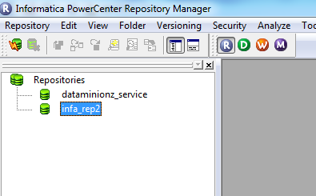

Now we can login into repository using domain login ID/password.